**Assignment No. 1**

* ***Aim:***

Demonstration of parts (by dismantling the meter) of various electrochemical meters. Explanation of symbols and notations used on instruments.

* ***Apparatus:***

Voltmeter, Ammeter, Rish Digital Display meter, Secure Elite 440 Digital Display meter and Screwdriver.

* ***Objective:***

1. To demonstrate parts of electrochemical meters.

2. To explain the symbols and notations used on instruments.

* ***Outcome:***

Students will be able to:

1. Select and use instrument transformers.

2. Identify internal parts of various meters

* ***Theory:***

In this practical assignment, our goal was to explore the inner workings of electrochemical meters by dismantling voltmeters and ammeters. By examining the various components, such as wires of different widths, mirrors, and springs, we gained an understanding of their significance. We delved into the operating principles of ammeters, which rely on the magnetic effect of electric current, and voltmeters, which are based on Ohm's Law.

We also learned about the correct procedures for connecting these meters in a circuit—ammeters in series and voltmeters in parallel—to ensure accurate readings and safe usage. Our exploration extended to digital meters like the Secure Elite 440 digital display meter, where we discovered their capabilities in measuring a wide range of electrical parameters.

The essential components of electrochemical meters contribute to their functionality and accuracy. The pointer, intricately linked to the coil, smoothly traverses a calibrated scale, providing a visual representation of the measured voltage or current. The scale itself serves as the calibrated section that displays the quantitative measurement, showcasing volts for voltmeters and amperes for ammeters. To enhance the versatility of ammeters, they may incorporate internal resistance, often referred to as shunt resistance, connected in parallel to the coil. This shunt resistance enables ammeters to measure high currents without jeopardizing the integrity of the meter movement. Additionally, the terminals or connections of the meter serve as crucial points where the voltage or current under examination is linked to ensure accurate readings. Understanding these key components deepens our knowledge of the intricate workings of electrochemical meters.

## Symbols & Notations:

1. **V or E for Voltage:** Voltmeters are represented by the symbol "V" or sometimes "E" in circuit diagrams. For AC voltmeters, "~V" or "~E" symbols are used.
2. **A for Amperes:** Ammeters are represented by the symbol "A" in circuit diagrams. For AC ammeters, "~A" symbols are used.
3. **Symbols for Meters in Circuit Diagrams:** In circuit diagrams, these meters are represented by their respective symbols connected in parallel for voltmeters and in series for ammeters.

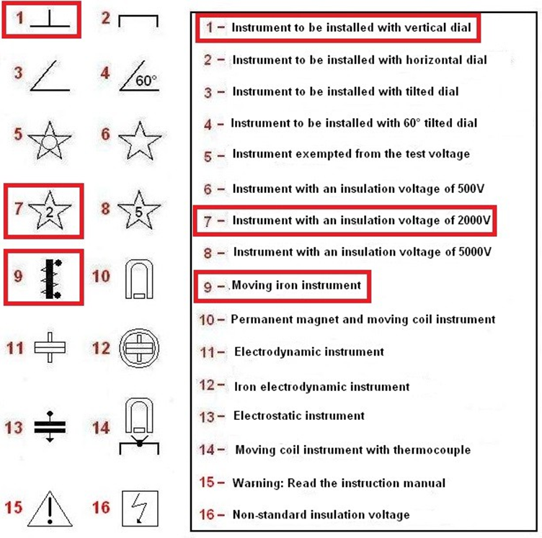

* ***Images:***

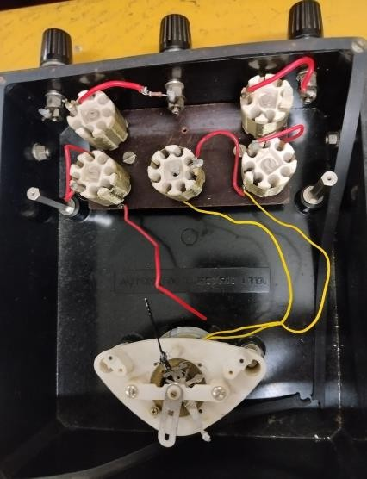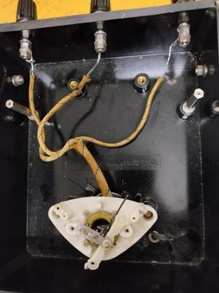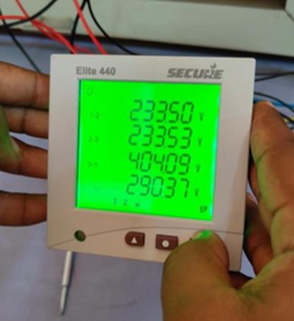

**Figure 1: Voltmeter Figure 2: Ammeter Figure 3: Digital Display Meter**

* ***Conclusion:***

In conclusion, we've effectively grasped the inner components of ammeters, voltmeters, and digital display meters. We now understand how they work, the connections within them, and the correct way to set them up in a circuit.